**Coding Assignment-Associate Software Engineer**

**Java**

**1.Create an array with the values (1,2,3,4,5,6,7) and shuffle it.**

import java.util.Arrays;

import java.util.Collections;

public class ShuffleArray

{

public static void main(String[] args)

{

Integer[] arr = {1, 2, 3, 4, 5, 6, 7};

Collections.shuffle(Arrays.asList(arr));

System.out.println(Arrays.toString(arr));

}

}

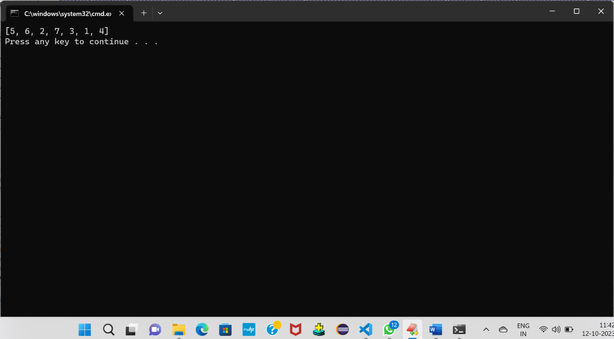

**2. Enter a Roman number as input and convert it to an integer.**

**import java.util.HashMap;**

**public class RomanToInteger**

**{**

**public static int romanToInt(String romanNumeral)**

**{**

**HashMap<Character, Integer> romanValues = new HashMap<>();**

**romanValues.put('I', 1);**

**romanValues.put('V', 5);**

**romanValues.put('X', 10);**

**romanValues.put('L', 50);**

**romanValues.put('C', 100);**

**romanValues.put('D', 500);**

**romanValues.put('M', 1000);**

**int result = 0;**

**int prevValue = 0;**

**for (int i = romanNumeral.length() - 1; i >= 0; i--)**

**{**

**int currValue = romanValues.get(romanNumeral.charAt(i));**

**if (currValue >= prevValue)**

**{**

**result += currValue;**

**}**

**else**

**{**

**result -= currValue;**

**}**

**prevValue = currValue;**

**}**

**return result;**

**}**

**public static void main(String[] args)**

**{**

**String romanNumeral = "XIV";**

**int integerValue = romanToInt(romanNumeral);**

**System.out.println(integerValue);**

**}**

**}**

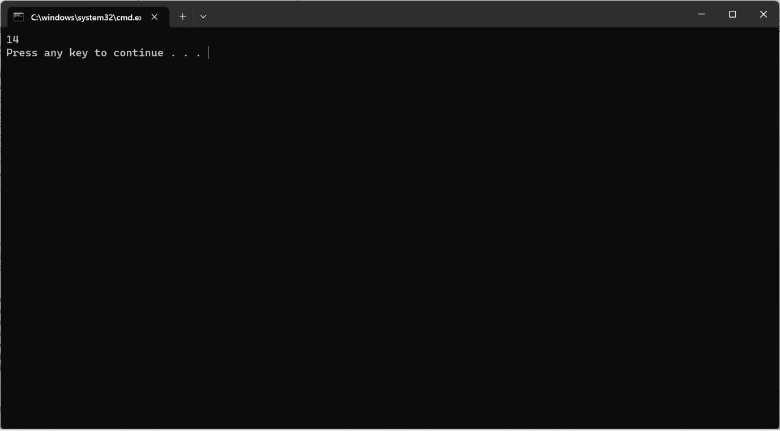

**3.Check if the input is pangram or not.**

**public class PangramChecker**

**{**

**public static boolean isPangram(String str)**

**{**

**str = str.toLowerCase();**

**boolean[] letters = new boolean[26];**

**for (int i = 0; i < str.length(); i++)**

**{**

**char c = str.charAt(i);**

**if (c >= 'a' && c <= 'z')**

**{**

**letters[c - 'a'] = true;**

**}**

**}**

**for (boolean letter : letters)**

**{**

**if (!letter)**

**{**

**return false;**

**}**

**}**

**return true;**

**}**

**public static void main(String[] args)**

**{**

**String input = "The quick brown fox jumps over the lazy dog";**

**boolean isPangram = isPangram(input);**

**if (isPangram)**

**{**

**System.out.println("The input is a pangram.");**

**} else {**

**System.out.println("The input is not a pangram.");**

**}**

**}**

**}**

**Java Script**

**1.Take a sentence as an input and reverse every word in that sentence.**

**import java.util.*;**

**public class ReverseWords {**

**public static void main(String[] args) {**

**Scanner scanner = new Scanner(System.in);**

**System.out.print("Enter a sentence: ");**

**String sentence = scanner.nextLine();**

**String[] words = sentence.split(" ");**

**StringBuilder reversedSentence = new StringBuilder();**

**for (String word : words) {**

**StringBuilder reversedWord = new StringBuilder(word);**

**reversedWord.reverse();**

**reversedSentence.append(reversedWord).append(" ");**

**}**

**System.out.println("Reversed sentence: " + reversedSentence.toString().trim());**

**}**

**}**

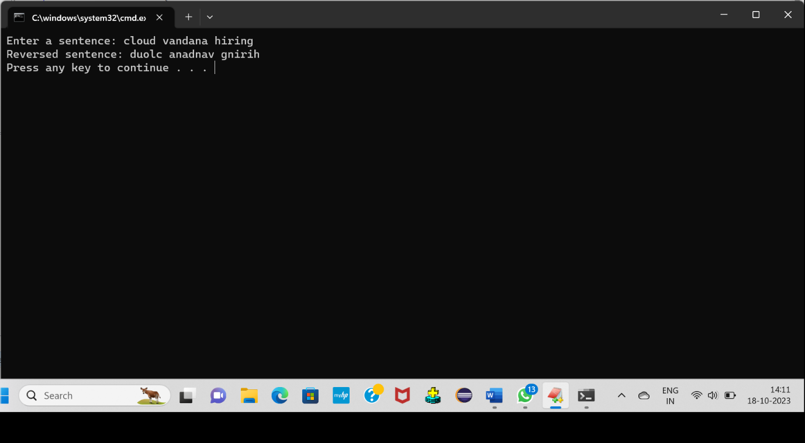

**2. Perform sorting of an array in descending order.**

**import java.util.Arrays;**

**import java.util.Collections;**

**public class SortArrayDescending {**

**public static void main(String[] args) {**

**Integer[] array = {5, 2, 9, 1, 7};**

**// Sort array in descending order**

**Arrays.sort(array, Collections.reverseOrder());**

**// Print the sorted array**

**System.out.println("Sorted array in descending order: " + Arrays.toString(array));**

**}**

**}**

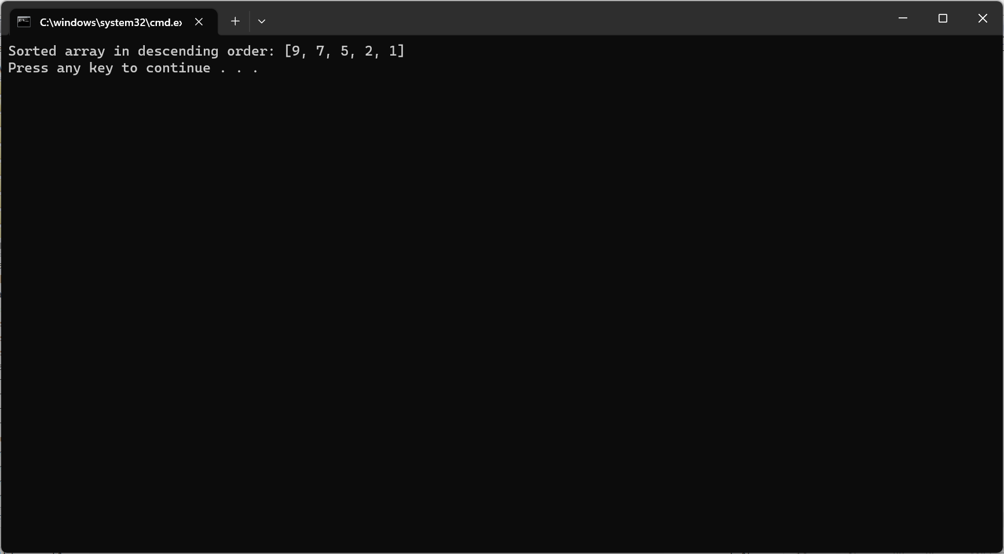

**HTML**

**1. Create a basic calculator using HTML, CSS, and JavaScript with the functionality of add,**

**subtract, multiply and divide. Use the following picture for reference**

<!DOCTYPE html>

<html lang="en">

<head>

<title>Document</title>

<link  rel="stylesheet" href="./index.css">

</head>

<body>

   <div id="container">

    <form name="calc">

        <input id="display" name="Answers" readonly>

        <br><br>

        <input class="buttons" type="button" value="1" onclick="calc.Answers.value+='1'" onmousedown="clickAudio()">

        <input class="buttons" type="button" value="2" onclick="calc.Answers.value+='2'" onmousedown="clickAudio()">

        <input class="buttons" type="button" value="3" onclick="calc.Answers.value+='3'" onmousedown="clickAudio()">

        <input class="buttons" type="button" value="+" onclick="calc.Answers.value+='+'" onmousedown="clickAudio()">

        <br><br>

        <input  class="buttons" type="button" value="4" onclick="calc.Answers.value+='4'" onmousedown="clickAudio()">

        <input  class="buttons" type="button" value="5" onclick="calc.Answers.value+='5'" onmousedown="clickAudio()">

        <input  class="buttons" type="button" value="6" onclick="calc.Answers.value+='6'" onmousedown="clickAudio()">

        <input  class="buttons" type="button" value="-" onclick="calc.Answers.value+='-'" onmousedown="clickAudio()">

        <br><br>

        <input class="buttons" type="button" value="7" onclick="calc.Answers.value+='7'" onmousedown="clickAudio()">

        <input class="buttons" type="button" value="8" onclick="calc.Answers.value+='8'" onmousedown="clickAudio()">

        <input class="buttons" type="button" value="9" onclick="calc.Answers.value+='9'" onmousedown="clickAudio()">

        <input class="buttons" type="button" value="*" onclick="calc.Answers.value+='*'" onmousedown="clickAudio()">

        <br><br>

        <input  class="buttons" type="button" value="/" onclick="calc.Answers.value+='/'" onmousedown="clickAudio()">

        <input  class="buttons" type="button" value="0" onclick="calc.Answers.value+='0'" onmousedown="clickAudio()">

        <input  class="buttons" type="button" value="." onclick="calc.Answers.value+='.'" onmousedown="clickAudio()">

        <input  class="buttons" type="button" value="%" onclick="calc.Answers.value+='%'" onmousedown="clickAudio()">

        <br><br>

        <input  id="clearButton" type="button" value="clear"  onclick="calc.Answers.value=''" onmousedown="clickAudio()">

        <input  id="equalButton" type="button"  value="="  onclick="calc.Answers.value=eval(calc.Answers.value)" onmousedown="clickAudio()">

    </form>

   </div>

</body>

</html>

*{

    padding: 0px;

    margin: 0px;

}

body{

    width: 100%;

    height: 100vh;

    background-image: linear-gradient(125 deg,black,lightblue);

    background-repeat: no-repeat;

    background-size: 100%,100vh;

    display: flex;

    justify-content: center;

    align-items: center;

}

#container{

    width: 300px;

    height:400px;

    background-color: rgb(131, 61, 61,0.496);

    border-radius: 10px;

    box-shadow: 5px 5px 5px black;

    display: flex;

    justify-content: center;

    align-items: center;

}

form{

    width: 100%;

    height: 100%;

    position: relative;

}

#display{

    width: 80%;

    height: 30px;

    position: absolute;

    top: 20px;

    left: 8%;

    border: none;

    outline: none;

    border-radius: 5px;

    background-color: black;

    color: white;

    font-size: 18px;

    padding: 5px;

    box-shadow: 5px 5px 5px black;

    border: 2px solid white;

}

.buttons,#clearButton,#equalButton{

    width: 40px;

    height: 30px;

    position: relative;

    top: 15%;

    left: 8%;

    margin-left: 5%;

    margin-top: 5%;

    background-color: black;

    color: white;

    border: none;

    border-radius: 5px;

    font-size: 21px;

    cursor: pointer;

    transition: transform 0.2s;

}

.buttons:hover,#clearButton:hover{

    box-shadow: 2px 2px 5px black;

    transform: scale(1.08);

    background-color: white;

    color: black;

}

#clearButton{

    width: 40%;

}

#equalButton{

    width: 30%;

    background-color: red;

    color: black;

    transition: trqansform 0.2s;

}

#equalButton:hover{

    background-color: lawngreen;

    box-shadow: 2px 2px 5px black;

    transform: scale(1.08);

}

var clickSound=new Audio()

clickSound.src="C:\Users\koppu\Downloads\click.wav"

function clickAudio()

{

    clickSlund.play()

}

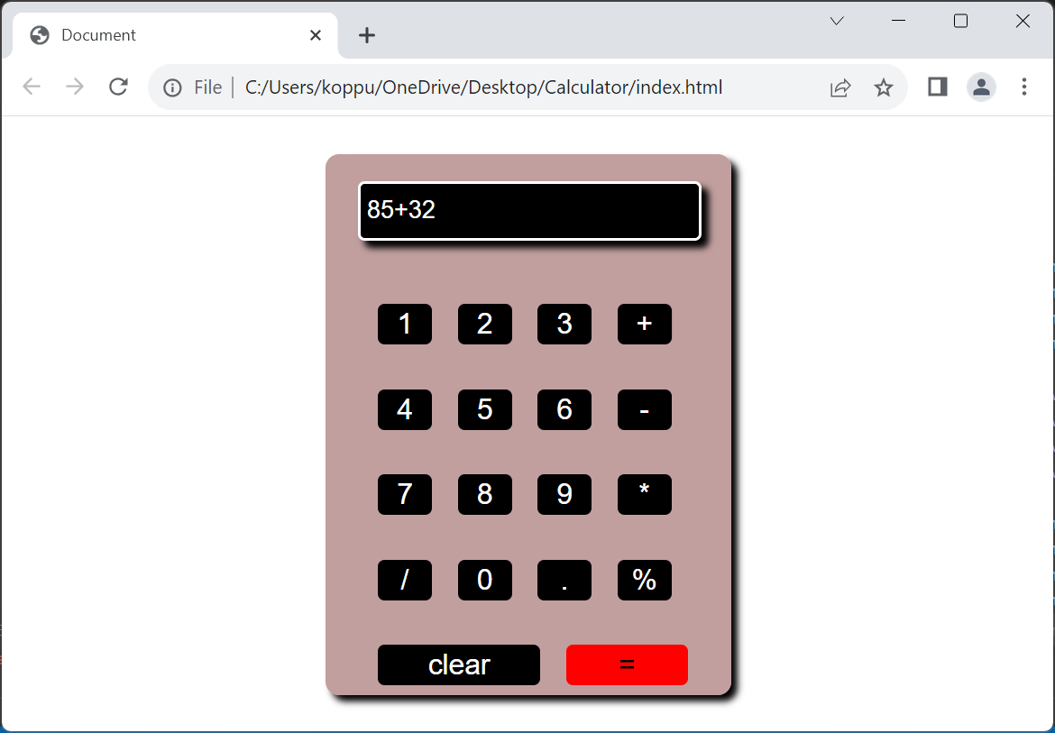

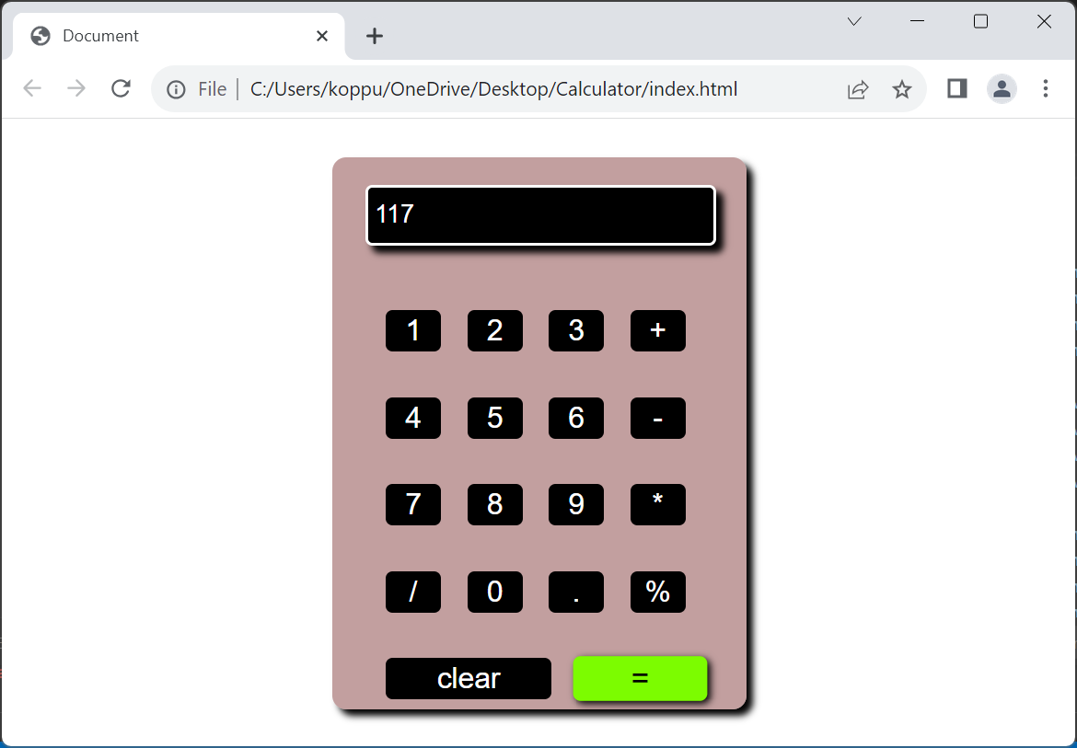

**2.** **Create a survey form with Fields; First Name, Last Name, Date of Birth, Country (dropdown),**

**Gender (checkbox), Profession, email, and mobile number. All the input fields are**

**necessary to submit the form. Create two buttons Submit and Reset. Reset will reset the**

**form while clicking on submit, first, it will check all the fields and necessary validations and**

**then a popup will appear displaying all the selected values with the label in front of it. On**

**closing the popup, the form should reset all the values. Use the following for reference.**

<!DOCTYPE html>

<html>

<head>

    <title>Survey Form</title>

    <style>

        .container {

            max-width: 500px;

            margin: 0 auto;

            padding: 10px;

        }

        .form-group {

            margin-bottom: 20px;

        }

        .form-group label {

            display: block;

            margin-bottom: 5px;

        }

        .form-group input, .form-group select {

            width: 100%;

            padding: 10px;

        }

        .form-group input[type="checkbox"] {

            width: auto;

        }

        .button-container {

            text-align: center;

        }

        .button-container button {

            padding: 10px 20px;

            margin-right: 10px;

        }

    </style>

</head>

<body>

    <div id="glowColorEffect"></div>

    <div class="container">

        <form id="surveyForm">

            <div class="form-group">

                <label for="firstName">First Name:</label>

                <input type="text" id="firstName" required>

            </div>

            <div class="form-group">

                <label for="lastName">Last Name:</label>

                <input type="text" id="lastName" required>

            </div>

            <div class="form-group">

                <label for="dob">Date of Birth:</label>

                <input type="date" id="dob" required>

            </div>

            <div class="form-group">

                <label for="email">Email:</label>

                <input type="text" id="email" required>

            </div>

            <div class="form-group">

                <label for="phno">phno:</label>

                <input type="tel" id="phno" required>

            </div>

            <div class="form-group">

                <label for="country">Country:</label>

                <select id="country" required>

                    <option value="">Select Country</option>

                    <option value="USA">USA</option>

                    <option value="Canada">Canada</option>

                    <option value="UK">UK</option>

                    <option value="India">India</option>

                </select>

            </div>

            <div class="form-group">

                <label>Gender:</label>

                <input type="checkbox" id="male" name="gender" value="Male">

                <label for="male">Male</label>

                <input type="checkbox" id="female" name="gender" value="Female">

                <label for="female">Female</label>

            </div>

            <input type="reset">

            <input type="submit" onclick="storeData()">

